INDEX

S. N  o | Date | LIST OF EXPERIMENTS | Page No. | Marks | Sign
A python program to implement univariate
regression, bivariate regression and multivariate regression.
 |  | A python program to implement Simple linear regression using Least Square Method
 |  | A python program to implement logistic model.
 |  | A python program to implement single layer perceptron.
A python program to implement multi layer
perceptron with back propagation
 |  | A python program to do face recognition using SVM classifier
 |  | A python program to implement decision tree.
 |  | A python program to implement boosting
 |  | A python program to implement KNN and K- means
 |  | A python program to implement dimensionality reduction – PCA.
 |  | Mini project – develop a simple application using tensorflow / keras.
 |  | Cbs:Traffic Sign Recognition Using CNN

Ex. No. 1 | UNIVARIATE ,BIVARIATE AND MULTIVARIATE REGRESSION

Aim
To write a Python program for Univariate, Bivariate and Multivariate Regression.

Algorithm

Univariate Linear Regression

- Start
- Import required libraries
- Load or create the dataset
- Select one independent variable X
- Select dependent variable y
- Create a Linear Regression model
- Train the model using X and y
- Predict y pred from X
- Calculate performance metrics (R², MSE)
- Display coefficients and performance
- End

Algorithm for Bivariate Linear Regression

- Start
- Import required libraries
- Load or create the dataset
- Select two independent variables X1 and X2
- Combine X1 and X2 into feature matrix X
- Select dependent variable y
- Create a Linear Regression model
- Train the model using X and y
- Predict y pred from X
- Calculate performance metrics (R², MSE)
- Display coefficients and performance
- End

Algorithm for Multivariate Linear Regression

- Start
- Import required libraries
- Load or create the dataset
- Select more than two independent variables X1, X2, ..., Xn
- Combine all independent variables into feature matrix X
- Select dependent variable y
- Create a Linear Regression model
- Train the model using X and y
- Predict y_pred from X
- Calculate performance metrics (R², MSE)
- Display coefficients and performance
- End

Program
import numpy as np
import matplotlib.pyplot as plt
from sklearn.linear_model import LinearRegression
from sklearn.metrics import mean_squared_error, r2_score def evaluate_model(model, X, y, name="Model"):
predictions = model.predict(X) print(f"\n{name} Performance:") print("Coefficients:", model.coef_) print("Intercept:", model.intercept_)
print("MSE:", mean_squared_error(y, predictions)) print("R2 Score:", r2_score(y, predictions))
return predictions
print("=== Univariate Regression ===")
X_uni = np.random.rand(100, 1) * 10
y_uni = 3 * X_uni.squeeze() + 4 + np.random.randn(100) model_uni = LinearRegression()
model_uni.fit(X_uni, y_uni)
pred_uni = evaluate_model(model_uni, X_uni, y_uni, "Univariate Regression") plt.figure(figsize=(6, 4))
plt.scatter(X_uni, y_uni, color="blue", label="Actual")

plt.plot(X_uni, pred_uni, color="red", label="Predicted") plt.title("Univariate Linear Regression")
plt.xlabel("X")
plt.ylabel("y") plt.legend() plt.grid(True) plt.show()
print("\n=== Bivariate Regression ===")
X_bi = np.random.rand(100, 2) * 10
y_bi = 2 * X_bi[:, 0] + 5 * X_bi[:, 1] + 3 + np.random.randn(100) model_bi = LinearRegression()
model_bi.fit(X_bi, y_bi)
pred_bi = evaluate_model(model_bi, X_bi, y_bi, "Bivariate Regression") print("\n=== Multivariate Regression ===")
# Generate synthetic data
X_multi = np.random.rand(100, 5) * 10 # Create target with 5 predictors
y_multi = (1.5 * X_multi[:, 0] + 2.2 * X_multi[:, 1] +
0.5 * X_multi[:, 2] - 1.2 * X_multi[:, 3] +
3.3 * X_multi[:, 4] + 5 + np.random.randn(100)) model_multi = LinearRegression() model_multi.fit(X_multi, y_multi)
pred_multi = evaluate_model(model_multi, X_multi, y_multi, "Multivariate Regression")

Output
=== Univariate Regression === Univariate Regression Performance:
Coefficients: [3.04241453]
Intercept: 3.586891995302219
MSE: 0.9630107279246621
R2 Score: 0.9881435560730226
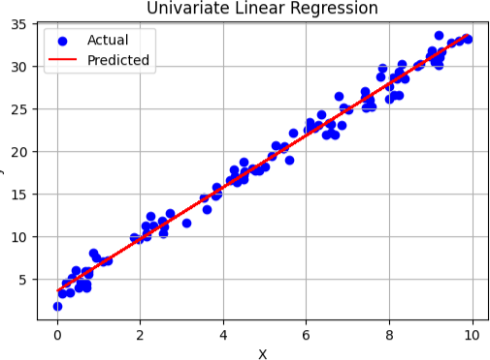
=== Bivariate Regression === Bivariate Regression Performance:
Coefficients: [2.01962213 4.96940366]
Intercept: 3.044137108247348
MSE: 1.0027759173747084
R2 Score: 0.9960031925945165
=== Multivariate Regression === Multivariate Regression Performance:
Coefficients: [ 1.48614347 2.24173582 0.51087548 -1.12956551 3.23143593]
Intercept: 4.86045813338108
MSE: 0.9578935289935879
R2 Score: 0.994364056625958

Result
Thus the python program for executing Univariate Regression ,Bivraite Regression and Multivariate Regression has been executed successfully.

Ex. No. 2 | SIMPLE LINEAR REGRESSION USING LEAST SQUARE METHOD

Aim
To implement Simple Linear Regression using the Least Squares Method in Python and analyze
the relationship between two variables.

Algorithm

- Start
- Import required libraries
- Input or load the dataset (X and Y values)
- Calculate the means of X and Y
- Compute slope (m) using the formula:
- 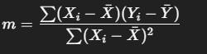
- Compute intercept (c) using:
- 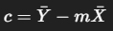
- Calculate predicted values (Ŷ) for each X using:
- 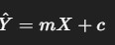
- Evaluate model using metrics like R² Score or Mean Squared Error (MSE)
- Display results (slope, intercept, predicted values, error metrics)
- End

Program
import numpy as np
import matplotlib.pyplot as plt X = np.array([1, 2, 3, 4, 5])
y = np.array([2, 4, 5, 4, 5]) mean_x = np.mean(X) mean_y = np.mean(y)
numerator = np.sum((X - mean_x) * (y - mean_y)) denominator = np.sum((X - mean_x) ** 2)
slope = numerator / denominator intercept = mean_y - slope * mean_x

print("Slope (m):", slope) print("Intercept (c):", intercept) y_pred = slope * X + intercept
plt.scatter(X, y, color='blue', label='Actual data') plt.plot(X, y_pred, color='red', label='Regression line') plt.title('Simple Linear Regression (Least Squares)') plt.xlabel('X')
plt.ylabel('y') plt.legend() plt.grid(True) plt.show()
ss_total = np.sum((y - mean_y) ** 2) ss_residual = np.sum((y - y_pred) ** 2) r2_score = 1 - (ss_residual / ss_total) print("R² Score:", r2_score)

Output
Slope (m): 0.6
Intercept (c): 2.2
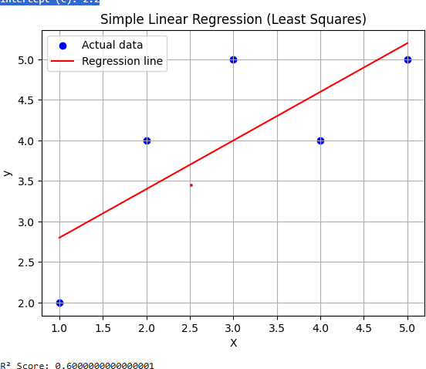

Result
Thus the python program for to implement Simple Linear Regression using the Least Squares
Method in python and analyze the relationship between two variables.

Ex. No. 3 | LOGISTIC MODEL

Aim
To implement a Logistic Regression Model in Python to classify binary outcomes and evaluate its
performance using appropriate metrics. Algorithm
- Start
- Import required libraries
- Load or create the dataset with independent variables X and binary target variable y (0 or 1)
- Preprocess the data (if needed: clean, normalize, split)
- Split the dataset into training and testing sets
- Initialize the Logistic Regression model
- Train the model using the training data
- Predict the output for the test data
- Evaluate the model using metrics:
- Accuracy
- Confusion Matrix
- Precision, Recall, F1-score
- Display coefficients, intercept, and evaluation results
- End

Program
import numpy as np
import matplotlib.pyplot as plt
from sklearn.datasets import make_classification from sklearn.model_selection import train_test_split from sklearn.metrics import accuracy_score
def sigmoid(z):
return 1 / (1 + np.exp(-z)) class LogisticRegressionScratch:
def init (self, learning_rate=0.01, epochs=1000): self.learning_rate = learning_rate
self.epochs = epochs def fit(self, X, y):
self.m, self.n = X.shape

self.weights = np.zeros(self.n) self.bias = 0
for _ in range(self.epochs):
linear_model = np.dot(X, self.weights) + self.bias y_pred = sigmoid(linear_model)
dw = (1 / self.m) * np.dot(X.T, (y_pred - y)) db = (1 / self.m) * np.sum(y_pred - y) self.weights -= self.learning_rate * dw self.bias -= self.learning_rate * db
def predict(self, X):
linear_model = np.dot(X, self.weights) + self.bias y_pred = sigmoid(linear_model)
return [1 if i > 0.5 else 0 for i in y_pred]
X, y = make_classification(n_samples=100, n_features=2, n_redundant=0, n_clusters_per_class=1, random_state=42)
X_train, X_test, y_train, y_test = train_test_split(X, y, test_size=0.2, random_state=42) model = LogisticRegressionScratch(learning_rate=0.1, epochs=1000) model.fit(X_train, y_train)
y_pred = model.predict(X_test)
print("Accuracy (scratch):", accuracy_score(y_test, y_pred)) from sklearn.linear_model import LogisticRegression
clf = LogisticRegression() clf.fit(X_train, y_train) y_sklearn = clf.predict(X_test)
print("Accuracy (scikit-learn):", accuracy_score(y_test, y_sklearn)) def plot_decision_boundary(model, X, y):
x_min, x_max = X[:, 0].min() - 1, X[:, 0].max() + 1
y_min, y_max = X[:, 1].min() - 1, X[:, 1].max() + 1 xx, yy = np.meshgrid(np.linspace(x_min, x_max, 100),
np.linspace(y_min, y_max, 100)) grid = np.c_[xx.ravel(), yy.ravel()]
preds = np.array(model.predict(grid)).reshape(xx.shape) plt.contourf(xx, yy, preds, alpha=0.3, cmap='coolwarm') plt.scatter(X[:, 0], X[:, 1], c=y, cmap='coolwarm', edgecolors='k') plt.title("Logistic Regression Decision Boundary") plt.xlabel("Feature 1")
plt.ylabel("Feature 2")

plt.grid(True) plt.show()
plot_decision_boundary(model, X, y)

Output
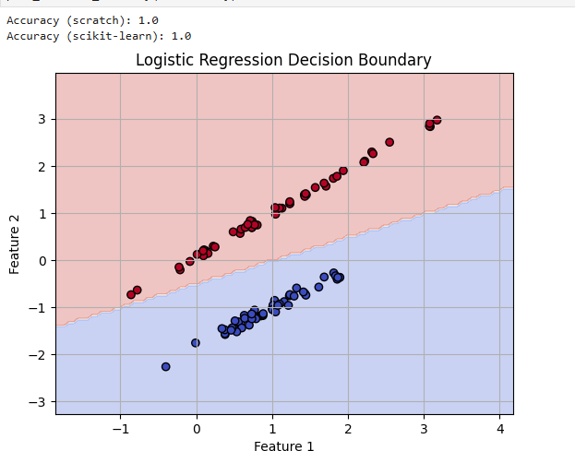

Result
Thus the python program to implement a Logistic Regression Model in Python to classify binary
outcomes and evaluate its performance using appropriate metrics

Ex. No. 4 | SINGLE LAYER PERCEPTRON

Aim
To implement a Single Layer Perceptron in Python for binary classification and demonstrate its
learning using a simple linearly separable dataset.

Algorithm

- Start
- Import necessary libraries (e.g., NumPy)
- Initialize input features X and target output y
- Set learning rate (α), number of epochs, and initialize weights and bias to small random values or zeros
- For each epoch (iteration over the entire dataset):
  - For each input sample:
    - Calculate the weighted sum:
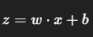

    - Apply the activation function (step function):
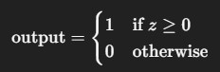

    - Update the weights and bias using the Perceptron learning rule:
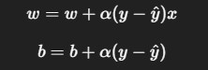

- Repeat until convergence or max epochs reached
- Test the perceptron on new inputs
- Display final weights, bias, and outputs
- End

Program

import numpy as np
from sklearn.datasets import make_classification from sklearn.model_selection import train_test_split from sklearn.metrics import accuracy_score
import matplotlib.pyplot as plt def step_function(x):
return np.where(x >= 0, 1, 0) class Perceptron:
def init (self, learning_rate=0.01, epochs=1000): self.learning_rate = learning_rate
self.epochs = epochs def fit(self, X, y):
self.n_samples, self.n_features = X.shape self.weights = np.zeros(self.n_features) self.bias = 0
for _ in range(self.epochs):
for idx, x_i in enumerate(X):
linear_output = np.dot(x_i, self.weights) + self.bias y_pred = step_function(linear_output)
update = self.learning_rate * (y[idx] - y_pred) self.weights += update * x_i
self.bias += update def predict(self, X):
linear_output = np.dot(X, self.weights) + self.bias return step_function(linear_output)
X, y = make_classification(n_samples=100, n_features=2, n_informative=2, n_redundant=0, n_clusters_per_class=1, random_state=42)
y = np.where(y <= 0, 0, 1)
X_train, X_test, y_train, y_test = train_test_split(X, y, test_size=0.2, random_state=42) model = Perceptron(learning_rate=0.01, epochs=1000)
model.fit(X_train, y_train) y_pred = model.predict(X_test)
print("Accuracy:", accuracy_score(y_test, y_pred)) def plot_decision_boundary(X, y, model):
x_min, x_max = X[:, 0].min() - 1, X[:, 0].max() + 1
y_min, y_max = X[:, 1].min() - 1, X[:, 1].max() + 1

xx, yy = np.meshgrid(np.linspace(x_min, x_max, 100), np.linspace(y_min, y_max, 100))
grid = np.c_[xx.ravel(), yy.ravel()]
preds = model.predict(grid).reshape(xx.shape) plt.contourf(xx, yy, preds, alpha=0.4, cmap='coolwarm')
plt.scatter(X[:, 0], X[:, 1], c=y, cmap='coolwarm', edgecolors='k') plt.title("Single-Layer Perceptron Decision Boundary") plt.xlabel("Feature 1")
plt.ylabel("Feature 2") plt.grid(True) plt.show()
plot_decision_boundary(X, y, model)

Output
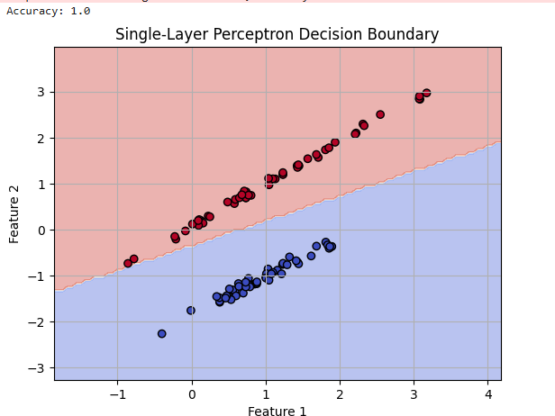

Result
Thus the python program to implement a Single Layer Perceptron in Python for binary classification
and demonstrate its learning using a simple linearly separable dataset has been executed successfully.

Ex. No. 5 | MULTI LAYER PERCEPTRON WITH BACKPROPAGATION

Aim
To implement a Multilayer Perceptron (MLP) using the Backpropagation algorithm in Python for
solving classification problems.

Algorithm

- Start
- Import required libraries (e.g., NumPy or TensorFlow/Keras)
- Initialize the dataset (features X, labels y)

- Initialize network architecture:

- Input layer size (based on input features)
- One or more hidden layers with neurons
- Output layer size (usually 1 for binary, n for multi-class)
- Initialize weights and biases randomly for all layers
- Set hyperparameters: learning rate α, number of epochs, activation functions (e.g., sigmoid, ReLU)

- For each epoch:

- For each training example:
a. Forward Propagation:
  - Compute activations for each layer using:
- 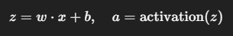
- Compute Loss (e.g., Mean Squared Error or Cross Entropy)
c. Backward Propagation:
- Compute gradients of the loss with respect to weights and biases (using chain rule)
- Propagate the error backward layer by layer
d. Update Weights and Biases using:
o 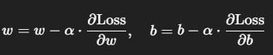
- Repeat until all epochs are completed or convergence
- Test the trained model on new data
- Display final weights, bias, and accuracy

- End

Program
import numpy as np
from sklearn.datasets import make_moons
from sklearn.model_selection import train_test_split import matplotlib.pyplot as plt
def sigmoid(x):
return 1 / (1 + np.exp(-x)) def sigmoid_derivative(x):
return x * (1 - x) class MLP:
def init (self, input_size, hidden_size, output_size): # Initialize weights and biases
self.W1 = np.random.randn(input_size, hidden_size) self.b1 = np.zeros((1, hidden_size))
self.W2 = np.random.randn(hidden_size, output_size) self.b2 = np.zeros((1, output_size))
def forward(self, X):
self.Z1 = np.dot(X, self.W1) + self.b1 self.A1 = sigmoid(self.Z1)
self.Z2 = np.dot(self.A1, self.W2) + self.b2 self.A2 = sigmoid(self.Z2)
return self.A2
def backward(self, X, y, output, learning_rate): m = y.shape[0]
error = output - y
dZ2 = error * sigmoid_derivative(output) dW2 = np.dot(self.A1.T, dZ2) / m
db2 = np.sum(dZ2, axis=0, keepdims=True) / m
dZ1 = np.dot(dZ2, self.W2.T) * sigmoid_derivative(self.A1) dW1 = np.dot(X.T, dZ1) / m
db1 = np.sum(dZ1, axis=0, keepdims=True) / m self.W1 -= learning_rate * dW1
self.b1 -= learning_rate * db1 self.W2 -= learning_rate * dW2 self.b2 -= learning_rate * db2

def train(self, X, y, epochs=1000, learning_rate=0.1): for epoch in range(epochs):
output = self.forward(X) self.backward(X, y, output, learning_rate) if epoch % 100 == 0:
loss = np.mean((y - output) ** 2) print(f"Epoch {epoch}, Loss: {loss:.4f}")
def predict(self, X):
output = self.forward(X)
return (output > 0.5).astype(int)
X, y = make_moons(n_samples=500, noise=0.2, random_state=42) y = y.reshape(-1, 1) # Make y 2D for output layer compatibility
X_train, X_test, y_train, y_test = train_test_split(X, y, test_size=0.2, random_state=42) mlp = MLP(input_size=2, hidden_size=5, output_size=1)
mlp.train(X_train, y_train, epochs=1000, learning_rate=0.1) y_pred = mlp.predict(X_test)
accuracy = np.mean(y_pred == y_test) print(f"\nTest Accuracy: {accuracy:.2f}") def plot_decision_boundary(model, X, y):
x_min, x_max = X[:, 0].min() - 0.5, X[:, 0].max() + 0.5
y_min, y_max = X[:, 1].min() - 0.5, X[:, 1].max() + 0.5 xx, yy = np.meshgrid(np.linspace(x_min, x_max, 200),
np.linspace(y_min, y_max, 200)) grid = np.c_[xx.ravel(), yy.ravel()]
preds = model.predict(grid).reshape(xx.shape) plt.contourf(xx, yy, preds, alpha=0.3, cmap="coolwarm")
plt.scatter(X[:, 0], X[:, 1], c=y.ravel(), cmap="coolwarm", edgecolors='k') plt.title("MLP Decision Boundary")
plt.xlabel("Feature 1")
plt.ylabel("Feature 2") plt.grid(True) plt.show()
plot_decision_boundary(mlp, X, y)

Output
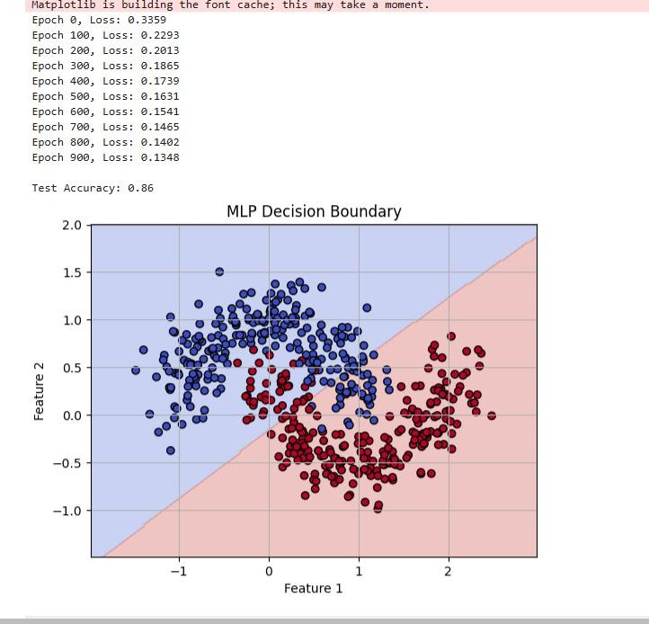

Result
Thus the python program to implement a Multilayer Perceptron (MLP) using the Backpropagation
algorithm in Python for solving classification problems.

Ex. No. 6 | FACE RECOGNITION USING SVM CLASSIFIER

Aim
To implement a Face Recognition System using a Support Vector Machine (SVM) classifier in
Python and classify facial images based on their encoded features.

Algorithm

- Start
- Import required libraries:
  - face_recognition for face detection and encoding
  - os for directory/file handling
  - sklearn.svm.SVC for SVM model
  - cv2 (OpenCV) for webcam/image capture (optional)
- Load dataset of face images (organized into subfolders, one per person)
- For each image in the dataset:
- Load the image
- Detect the face in the image
- Compute the face encoding (128-d feature vector)
- Store the encoding with the corresponding label (person’s name)
- Split the data into training and testing sets (optional)
- Train the SVM classifier on the face encodings and labels
- Test the model by:
- Capturing or loading a new image
- Detecting and encoding the face
- Predicting the identity using the trained SVM classifier
- Display the result (predicted name with confidence)
- End

Program
import numpy as np
import matplotlib.pyplot as plt
from sklearn.datasets import fetch_lfw_people
from sklearn.model_selection import train_test_split from sklearn.svm import SVC
from sklearn.decomposition import PCA

from sklearn.metrics import classification_report, confusion_matrix import seaborn as sns
lfw_people = fetch_lfw_people(min_faces_per_person=70, resize=0.4)
X = lfw_people.data # Flattened image data y = lfw_people.target # Target labels target_names = lfw_people.target_names n_classes = target_names.shape[0]
print("Total samples:", X.shape[0])
print("Image shape:", lfw_people.images[0].shape) print("Number of classes:", n_classes)
X_train, X_test, y_train, y_test = train_test_split(X, y, test_size=0.25, random_state=42) n_components = 100
pca = PCA(n_components=n_components, whiten=True).fit(X_train) X_train_pca = pca.transform(X_train)
X_test_pca = pca.transform(X_test)
clf = SVC(kernel='rbf', class_weight='balanced', C=1000, gamma=0.001) clf.fit(X_train_pca, y_train)
y_pred = clf.predict(X_test_pca) print("\nClassification Report:")
print(classification_report(y_test, y_pred, target_names=target_names)) plt.figure(figsize=(10, 6))
conf_mat = confusion_matrix(y_test, y_pred, labels=range(n_classes)) sns.heatmap(conf_mat, annot=True, fmt="d", cmap="Blues",
xticklabels=target_names, yticklabels=target_names) plt.title("Confusion Matrix")
plt.xlabel("Predicted") plt.ylabel("True") plt.show()
def plot_gallery(images, titles, h, w, n_row=3, n_col=5): plt.figure(figsize=(1.8 * n_col, 2.4 * n_row))
plt.subplots_adjust(bottom=0.01, left=0.01, right=0.99, top=0.90, hspace=0.35) for i in range(n_row * n_col):
plt.subplot(n_row, n_col, i + 1) plt.imshow(images[i].reshape((h, w)), cmap=plt.cm.gray) plt.title(titles[i], size=12)
plt.xticks(())
plt.yticks(())

def title(y_pred, y_true, target_names, i): pred_name = target_names[y_pred[i]].split()[-1] true_name = target_names[y_true[i]].split()[-1] return f'Pred: {pred_name}\nTrue: {true_name}'
prediction_titles = [title(y_pred, y_test, target_names, i) for i in range(y_pred.shape[0])] plot_gallery(X_test, prediction_titles, h=lfw_people.images.shape[1], w=lfw_people.images.shape[2]) plt.show()

Output
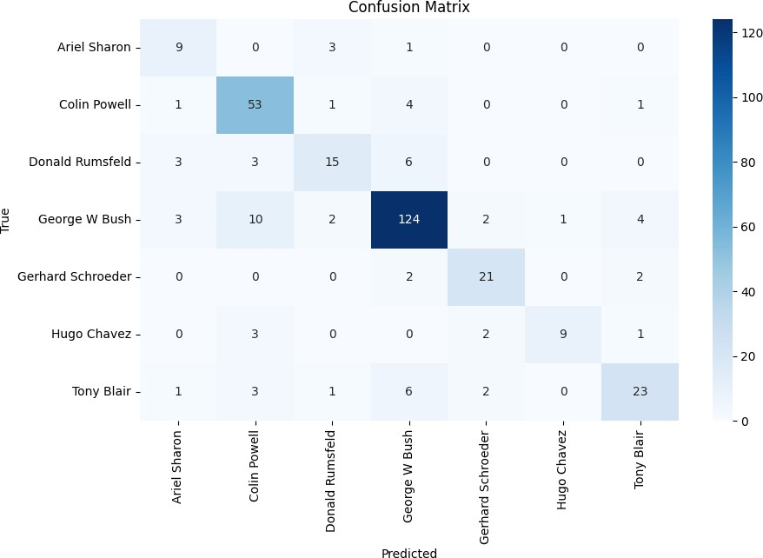
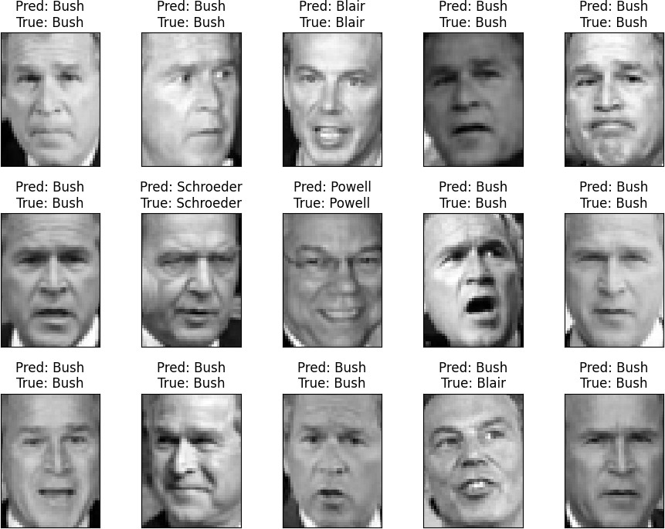

Result
Thus the program to implement a Face Recognition System using a Support Vector Machine (SVM)
classifier in Python and classify facial images based on their encoded features has been executed successfully.

Ex. No. 7 | DECISION TREE

Aim
To implement a Decision Tree Classifier in Python using a standard dataset and evaluate its
performance using classification metrics.

Algorithm

- Start
- Import necessary libraries (sklearn, pandas, numpy, etc.)
- Load the dataset (e.g., Iris, Breast Cancer, or any CSV file)
- Split the dataset into input features X and target labels y
- Preprocess the data if necessary (e.g., encoding, normalization)
- Divide the dataset into training and testing sets using train_test_split()
- Initialize the Decision Tree Classifier from sklearn.tree
- Train the model using the training data
- Make predictions using the test data
- Evaluate the model using metrics like:

  - Accuracy
  - Confusion matrix
  - Classification report

- Visualize the tree (optional, using plot_tree)
- Display the results
- End

Program
from sklearn.datasets import load_iris
from sklearn.model_selection import train_test_split
from sklearn.tree import DecisionTreeClassifier, plot_tree from sklearn.metrics import accuracy_score
import matplotlib.pyplot as plt iris = load_iris()
X = iris.data y = iris.target
X_train, X_test, y_train, y_test = train_test_split(X, y, test_size=0.2, random_state=42)

clf = DecisionTreeClassifier(criterion='gini', max_depth=3, random_state=42) clf.fit(X_train, y_train)
y_pred = clf.predict(X_test)
accuracy = accuracy_score(y_test, y_pred) print(f"Accuracy: {accuracy:.2f}") plt.figure(figsize=(12,8))
plot_tree(clf, feature_names=iris.feature_names, class_names=iris.target_names, filled=True) plt.title("Decision Tree Visualization")
plt.show()

Output
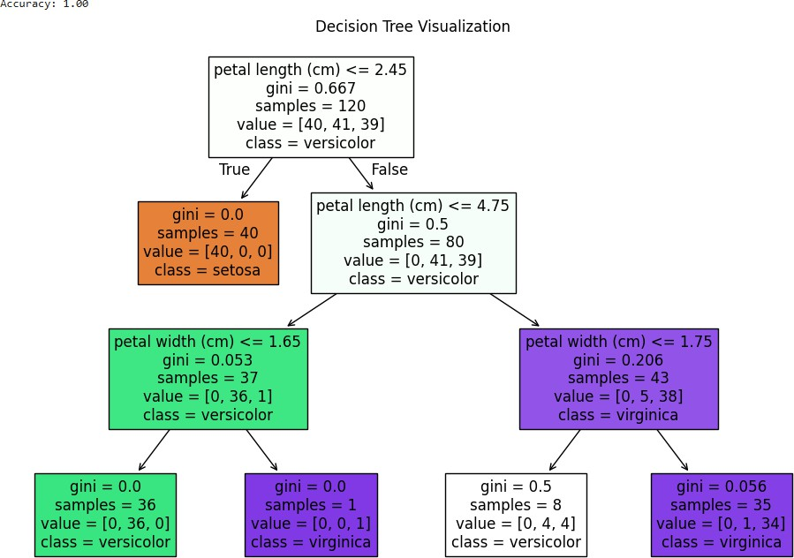

Result
Thus the python program to implement a Decision Tree Classifier in Python using a standard dataset
and evaluate its performance using classification metrics has been executed successfully.

Ex. No. 8 | BOOSTING

Aim
To implement the AdaBoost (Adaptive Boosting) algorithm using Decision Stump (a one-level
Decision Tree) as the weak learner and evaluate its performance on a synthetic classification dataset.. Algorithm
- Start the process.
- Generate or load a classification dataset.
- Split the dataset into training and testing sets.
- Create a decision stump using a decision tree classifier with max depth set to 1.
- Initialize the AdaBoost classifier using the decision stump as the base estimator, along with parameters like number of estimators and learning rate.
- Train the AdaBoost model on the training data.
- Use the trained model to predict the output on the test data.
- Evaluate the model using accuracy score, confusion matrix, and classification report.
- Plot the feature importances learned by the model.
- End the process.

Program
from sklearn.ensemble import AdaBoostClassifier from sklearn.tree import DecisionTreeClassifier from sklearn.datasets import make_classification from sklearn.model_selection import train_test_split
from sklearn.metrics import accuracy_score, classification_report, confusion_matrix import matplotlib.pyplot as plt
X, y = make_classification(n_samples=1000, n_features=10, n_informative=5, n_redundant=2, random_state=42)
X_train, X_test, y_train, y_test = train_test_split(X, y,
test_size=0.3, random_state=42)
base_estimator = DecisionTreeClassifier(max_depth=1)
model = AdaBoostClassifier(estimator=base_estimator, # <- changed here n_estimators=50,
learning_rate=1.0, random_state=42)
model.fit(X_train, y_train)

y_pred = model.predict(X_test)
print("Accuracy:", accuracy_score(y_test, y_pred)) print("\nConfusion Matrix:\n", confusion_matrix(y_test, y_pred))
print("\nClassification Report:\n", classification_report(y_test, y_pred)) plt.figure(figsize=(10, 6))
plt.bar(range(X.shape[1]), model.feature_importances_) plt.xlabel("Feature Index")
plt.ylabel("Importance")
plt.title("Feature Importances from AdaBoost") plt.show()

Output

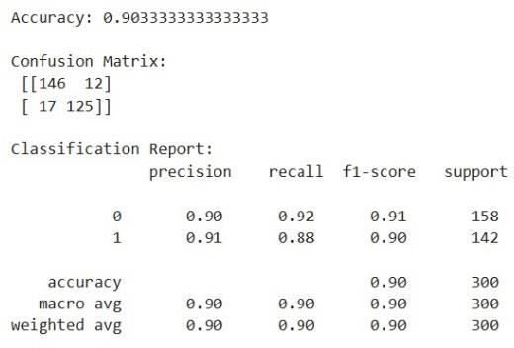

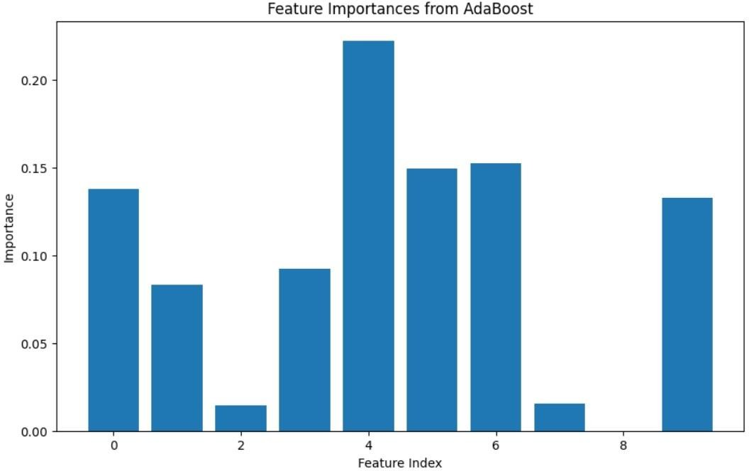

Result
Thus the program to implement a Boosting algorithm (e.g., AdaBoost) in Python using a standard
classification dataset and evaluate its performance.

Ex. No. 9 | KNN AND K MEANS CLUSTERING

Aim
To implement the K-Nearest Neighbors (KNN) algorithm for classification and K-means clustering
using a standard labeled dataset and evaluate its accuracy.

Algorithm KNN

- Start
- Import required libraries (numpy, sklearn, pandas)
- Load the labeled dataset (e.g., Iris)
- Preprocess the data if required (e.g., normalization)
- Split the dataset into training and testing sets
- Choose the value of k (number of neighbors)
- For each test data point:
  - Compute the distance from the test point to all training points
  - Select the k nearest neighbors
  - Assign the class most common among the neighbors
- Evaluate the model using accuracy or confusion matrix
- End

Program KNN
from sklearn.datasets import load_iris
from sklearn.model_selection import train_test_split from sklearn.neighbors import KNeighborsClassifier from sklearn.metrics import accuracy_score
iris = load_iris()
X, y = iris.data, iris.target
X_train, X_test, y_train, y_test = train_test_split(X, y, test_size=0.2, random_state=42) knn = KNeighborsClassifier(n_neighbors=3)
knn.fit(X_train, y_train) y_pred = knn.predict(X_test)
print("KNN Accuracy:", accuracy_score(y_test, y_pred))

Output
KNN Accuracy: 1.0 K means Clustering Algorithm

- Start
- Import required libraries (numpy, sklearn, matplotlib)
- Load the unlabeled dataset (or remove labels from a labeled dataset)
- Select the number of clusters k
- Randomly initialize k cluster centroids
- Repeat until convergence or max iterations:
  - Assign each data point to the nearest centroid
  - Recalculate centroids as the mean of assigned points
- Visualize the clusters (if 2D or 3D)
- End

Program

from sklearn.datasets import make_blobs from sklearn.cluster import KMeans import matplotlib.pyplot as plt
X, y_true = make_blobs(n_samples=300, centers=4, cluster_std=0.60, random_state=0) kmeans = KMeans(n_clusters=4, random_state=42)
kmeans.fit(X)
y_kmeans = kmeans.predict(X)
plt.scatter(X[:, 0], X[:, 1], c=y_kmeans, s=50, cmap='viridis') plt.scatter(kmeans.cluster_centers_[:, 0], kmeans.cluster_centers_[:, 1],
s=200, c='red', marker='X') plt.title("K-Means Clustering") plt.show()

Output
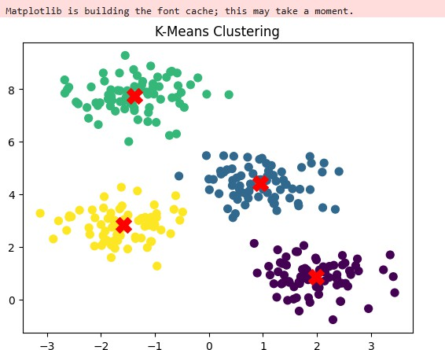

Result
Thus the program to implement the K-Nearest Neighbors (KNN) algorithm for classification and K-
means clustering using a standard labeled dataset and evaluate its accuracy has been executed successfully.

Ex. No. 10 | DIMENSIONALITY REDUCTION -PCA

Aim
To implement Principal Component Analysis (PCA) for dimensionality reduction and visualize the
transformed dataset in reduced dimensions

Algorithm

- Start
- Import required libraries (numpy, pandas, matplotlib, sklearn)
- Load the dataset (e.g., Iris, or any high-dimensional data)
- Preprocess the data (handle missing values, normalize if needed)
- Standardize the features (mean = 0, std = 1)
- Compute the covariance matrix of the features
- Calculate eigenvalues and eigenvectors of the covariance matrix
- Sort eigenvectors by decreasing eigenvalues
- Select top k eigenvectors to form the projection matrix
- Transform the original dataset into the new subspace using the projection matrix
- Visualize the reduced data (e.g., in 2D using a scatter plot)
- End

Program
import matplotlib.pyplot as plt
from sklearn.datasets import load_iris from sklearn.decomposition import PCA iris = load_iris()
X = iris.data y = iris.target
target_names = iris.target_names pca = PCA(n_components=2) X_r = pca.fit_transform(X)
print(f"Explained variance ratio of the 2 components: {pca.explained_variance_ratio_}") plt.figure(figsize=(8,6))
colors = ['navy', 'turquoise', 'darkorange']
for color, i, target_name in zip(colors, [0, 1, 2], target_names):
plt.scatter(X_r[y == i, 0], X_r[y == i, 1], color=color, lw=2, label=target_name)

plt.legend()
plt.title('PCA of Iris dataset') plt.xlabel('Principal Component 1')
plt.ylabel('Principal Component 2') plt.grid(True)
plt.show()

Output
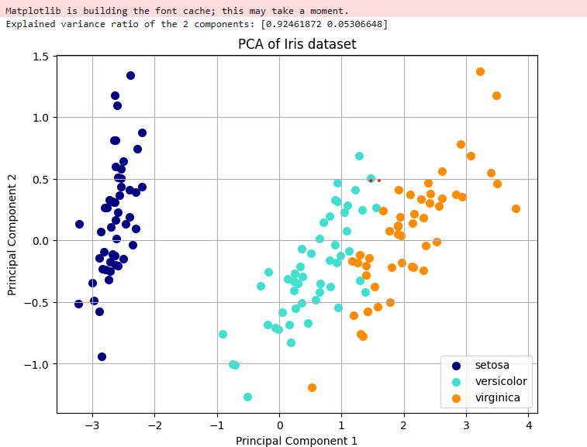

Result
Thus the python program to implement Principal Component Analysis (PCA) for dimensionality
reduction and visualize the transformed dataset in reduced dimensions has been executed successfully

Ex. No. 12 | TRAFFIC SIGN DETECTION USING CNN

Aim
To design and implement a Convolutional Neural Network (CNN) using Python and TensorFlow/Keras to recognize and classify traffic signs from the GTSRB dataset, thereby assisting in autonomous driving and traffic monitoring systems.

Algorithm
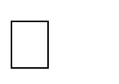
Import necessary libraries. Set the dataset path.
Initialize empty lists for images and labels. For each class folder from 0 to 42:
- Read each image.
- Resize the image to 32×32.
- Append image to the image list.
- Append the corresponding label to the label list. Convert image and label lists to NumPy arrays. Normalize the image data.
One-hot encode the labels.
Split the dataset into training and testing sets. Define the CNN model:
- Add Conv2D layer.
- Add MaxPooling2D layer.
- Add another Conv2D layer.
- Add another MaxPooling2D layer.
- Add Flatten layer.
- Add Dense layer with ReLU activation.
- Add Dropout layer.
- Add output Dense layer with softmax activation. Compile the model.
Train the model using training data. Evaluate the model using test data. Save the trained model.
Predict class for a new image.
Plot training and validation accuracy.

Program
import numpy as np import pandas as pd import os
import cv2
import matplotlib.pyplot as plt
from sklearn.model_selection import train_test_split from tensorflow.keras.utils import to_categorical from tensorflow.keras.models import Sequential
from tensorflow.keras.layers import Conv2D, MaxPooling2D, Flatten, Dense, Dropout data_dir = './gtsrb/Train' # Update if different
num_classes = 43 image_data = [] labels = []
print("Loading images...")
for class_id in range(num_classes):
class_path = os.path.join(data_dir, str(class_id)) if not os.path.exists(class_path):
continue
for img_file in os.listdir(class_path): try:
img_path = os.path.join(class_path, img_file) img = cv2.imread(img_path)
img = cv2.resize(img, (32, 32)) image_data.append(img) labels.append(class_id)
except:
continue
X = np.array(image_data) y = np.array(labels)
X = X / 255.0
y = to_categorical(y, num_classes)
X_train, X_test, y_train, y_test = train_test_split(X, y, test_size=0.2, random_state=42) model = Sequential([

Conv2D(32, (3,3), activation='relu', input_shape=(32,32,3)), MaxPooling2D(pool_size=(2,2)),

Conv2D(64, (3,3), activation='relu'), MaxPooling2D(pool_size=(2,2)), Flatten(),
Dense(128, activation='relu'), Dropout(0.5),
Dense(num_classes, activation='softmax')
])
model.compile(optimizer='adam', loss='categorical_crossentropy', metrics=['accuracy']) model.summary()
print("Training model...")
history = model.fit(X_train, y_train, epochs=10, batch_size=64, validation_data=(X_test, y_test)) loss, accuracy = model.evaluate(X_test, y_test)
print(f"Test Accuracy: {accuracy:.4f}") model.save("traffic_sign_cnn.h5") print("Model saved as traffic_sign_cnn.h5")
plt.plot(history.history['accuracy'], label='Training accuracy') plt.plot(history.history['val_accuracy'], label='Validation accuracy') plt.title('Model Accuracy Over Epochs')
plt.xlabel('Epoch') plt.ylabel('Accuracy') plt.legend() plt.grid(True) plt.show()
def predict_sign(image_path): img = cv2.imread(image_path) img = cv2.resize(img, (32, 32)) img = img / 255.0
img = img.reshape(1, 32, 32, 3) prediction = model.predict(img) class_index = np.argmax(prediction) confidence = np.max(prediction)

print(f"Predicted Class: {class_index}, Confidence: {confidence:.2f}") # predict_sign('./gtsrb/Test/00014.png')

Output
Loading images...
Total images loaded: 39209
Training model...
Epoch 1/10
492/492 [==============================] | - 12s | 23ms/step | - loss: | 1.6132 | - accuracy: | 0.5724 | -
val_loss: 0.5310 - val_accuracy: 0.8621
Epoch 2/10
492/492 [==============================] | - 11s | 23ms/step | - loss: | 0.4605 | - accuracy: | 0.8720 | -
val_loss: 0.2906 - val_accuracy: 0.9265
Epoch 3/10
492/492 [==============================] | - 11s | 23ms/step | - loss: | 0.2938 | - accuracy: | 0.9195 | -
val_loss: 0.2062 - val_accuracy: 0.9462
Epoch 4/10
492/492 [==============================] | - 11s | 23ms/step | - loss: | 0.2127 | - accuracy: | 0.9423 | -
val_loss: 0.1598 - val_accuracy: 0.9584
Epoch 5/10
492/492 [==============================] | - 11s | 23ms/step | - loss: | 0.1683 | - accuracy: | 0.9543 | -
val_loss: 0.1304 - val_accuracy: 0.9647
Epoch 6/10
492/492 [==============================] | - 11s | 22ms/step | - loss: | 0.1380 | - accuracy: | 0.9617 | -
val_loss: 0.1182 - val_accuracy: 0.9675
Epoch 7/10
492/492 [==============================] | - 11s | 22ms/step | - loss: | 0.1141 | - accuracy: | 0.9677 | -
val_loss: 0.1079 - val_accuracy: 0.9701
Epoch 8/10
492/492 [==============================] | - 11s | 22ms/step | - loss: | 0.0977 | - accuracy: | 0.9718 | -
val_loss: 0.1044 - val_accuracy: 0.9707
Epoch 9/10
492/492 [==============================] | - 11s | 23ms/step | - loss: | 0.0877 | - accuracy: | 0.9744 | -
val_loss: 0.0990 - val_accuracy: 0.9721
Epoch 10/10
492/492 [==============================] | - 11s | 23ms/step | - loss: | 0.0779 | - accuracy: | 0.9772 | -
val_loss: 0.0938 - val_accuracy: 0.9733

Evaluating on test set... Test Accuracy: 0.9733
Model saved as traffic_sign_cnn.h5

Result
Thus the python program to implement a Convolutional Neural Network (CNN) using
TensorFlow/Keras to recognize and classify traffic signs from the GTSRB dataset, thereby assisting in autonomous driving and traffic monitoring systems has been executed successfully.

